Automotive Technology

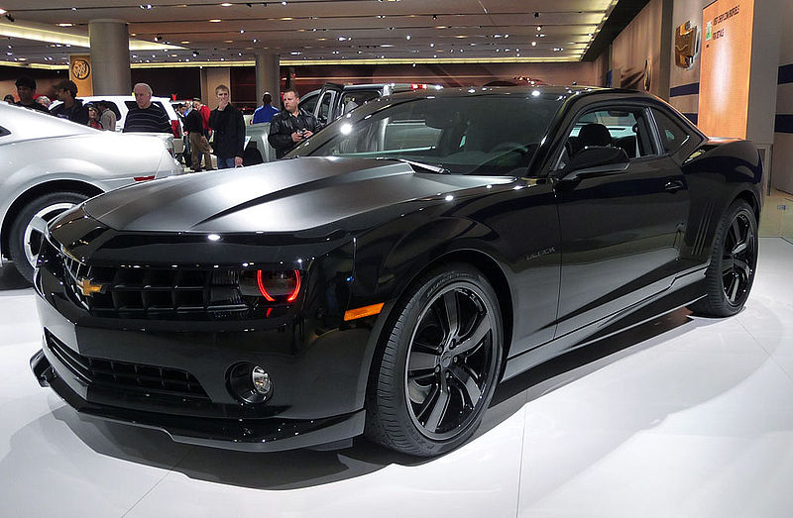

Lake Career & Technical Center
P.O. Box 1409
Camdenton, MO 65020
Phone (573)346-9260
Fax (573)346-9284
Instructor-Dennis Perkins
dperkins@ camdentonschools.org

Automotive Technology

CLASS DESCRIPTION:
(Grades: 11-12 - Credits: 3)
(Class may be repeated)

The Automotive Technology program meets the industry standards required for Automotive Service Excellence (ASE) certification in the areas of brakes, electrical/electronic systems, engine performance, and suspension and steering.

This program covers various aspects of engine analysis, including engine performance, diagnostics, and engine electronics. Also covered are brakes, electrical systems, fuel systems, electronic fuel injection, cooling systems, front-end alignment and suspension, charging systems, starting systems, electronic information research, repair orders, and cost estimates. Actual hands-on experience is provided using specialized automotive hand and power tools, engine analyzers, wheel alignment devices, and other state-of-the-art equipment.
This class also includes the opportunity to pursue embedded math credit.
With this class you are to be a member of SkillsUSA.

Learner Expectations:

At the end of this class you should have knowledge of the following:
A basic understanding of the different automotive systems
The many careers in the mechanic repair field
Tools related to the industry
Job seeking and job retention skills
Industry related math
Industry related reading

Course Rationale:

The goal of this class is to give the students a solid basis in automotive basics, thus giving them insight into the future education and career requirements to pursue this as a career opportunity. This class will also help guide the students toward a higher standard of excellence in the areas of job seeking skills along with building a strong work ethic, social skills and the importance of team work. Throughout the program we will focus on the basic academic skills needed to perform in any career, and will practice these skills in a class room setting and in a work related environment so as to promote better understanding of their importance.

Automotive Technology Expectations

- Please respect all individuals in the classroom.
- Please follow directions the first time they are given.
- Students should take notes during lecture and actively participate in class discussions.
- As a responsible student, you are expected to finish any project that you begin.
- Please raise your hand to be recognized in class before speaking during instructional and test time.
- Safety glasses must be worn in the lab area at all times.
- Only soft soled tennis shoes or work shoes can be allowed in the lab area.
- As you are now young adults please act that way accordingly.
- If you are absent from school, please contact me before or after school upon your return for any missed assignments.
- Please return all tools and equipment to proper storage area when not in use.
- Ask permission before leaving the classroom or lab area. (Hall pass required)
- Please be courteous when working around other student’s tools or projects.

Auto Tech

Power Standards

AT – Auto Tech

S Safety

ATS1. Shop Safety

ATS2. Tool Equipment Safety

TM Technical Math
TM1a Fractions
TM1b Measurements
TM1c Integers
TM1d Ratios

PE Business, Management and Technology- Demonstrate the ability to complete the employment process.
PE1a. Demonstrate the ability to complete an application.
PE1b. Demonstrate the ability to develop a resume.
PE1c. Demonstrate the ability to answer interview questions.

WE Work Ethics and CTSO.
WE1a Scoring Guide
WE1b Student Organization Participation

SS Steering and Suspension
ATSS1. Diagnose and repair steering systems.
ATSS2. Diagnose and repair suspension systems.
ATSS3. Diagnosis and adjustment of wheel alignment.
ATSS4. Diagnose and repair wheel and tire.

B Brakes
ATB1. Diagnose hydraulic system.
ATB2. Diagnose and repair drum brake.
ATB3. Diagnose and repair disc brake.
ATB4. Diagnose Power Assist Units.
ATB5. Demonstrate the ability to effectively use the principals of hydraulics by calculations of relative surface.

E Electronics
ATE1. Diagnose general electrical system.
ATE2. Diagnose battery.
ATE3. Diagnose starting system.
ATE4. Diagnose charging system.
ATE5. Diagnose lighting system.

EP Engine Performance
ATEP1. Diagnose general engine problems or complaints.
ATEP2. Diagnose computerized engine controls
ATEP3. Diagnose ignition system.
ATEP4. Diagnose fuel, air induction and exhaust systems.

A Adult Power Standards

ATA1. Preform a road force balance.
ATA2. Use diagnostic scanner on ABS system.
ATA3. Preform fuel system cleaning.

Grading System

Grading Procedure: Total points accumulated from all assignments will be used to establish the semester grade. The semester exam will be included in the cumulative semester grade. All students must take the semester exam and no exemptions will be allowed. The exam may be a combination of a performance and/or written assessment.

The following scale is used at LCTC to issue grades:

A 95% - 100% C 73% - 76%
A- 90% - 94% C- 70% - 72%
B+ 87% - 89% D+ 67% - 69%
B 83% - 86% D 63% - 66%
B- 80% - 82% D- 60% - 62%
C+ 77% - 79% F 59% and below

- Lab/Projects
- Work Ethics
- Technical Math Assignments
- Test/Quizzes (Examples: assessments, exams – written and/or performance, quizzes)

Make-Up and Incomplete Work: Students will be expected to complete all work at 80% or higher, or increase 25%.

